**Structural Functionalism Diagram**

Society

**Economics**

 

**Political**   **Norms & Values** **Education**

**CJ** (Criminal Justice)

 **Family**  

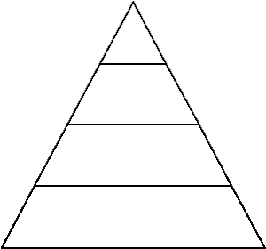Ivy League CEO

Private/UC System Lawyer

State Teacher

C.C McDonald’s



90210

Hood

**Economics**-

Structure: Capitalism

Function: Goods & Services, Division of Labor

**Education**-

Structure: Universal

Function: Knowledge & Skills, Obedience & Respect Authority, Selection

**Family**-

Structure: Nuclear Family

Function: Socialization, Reproduction

**Political**-

Structure: Democracy

Function: System of Governance

**CJ** (Criminal Justice)-

Structure: Police + Judiciary + Penal

Function: Resocialization